Fire Safety:
Fire safety reduces the risk of injury and building damage that fires can cause. At the Railway Children Upminster our fire safety protocol is frequently assessed to ensure that it is the most effective at ensuring the safety of all children, parents and staff.
The Manager and Designated Fire Marshalls make sure the nursery premises are compliant with fire safety regulations and seek advice from the local fire safety officer as necessary, including following any major changes or alterations to the premises. Our fire extinguishers are reassessed every year and new resources are provided when needed.
The Manager and Designated Fire Marshalls have overall responsibility for the fire drill and evacuation procedures. These are carried out and recorded every 6-8 weeks or as and when a large change occurs, for example, a large intake of children or a new team member joins the nursery. These drills will occur at different times of the day and on different days to ensure evacuations are possible under different circumstances and all children and staff participate in the rehearsals.
It is the managers role to ensure that adequate checks on the fire detectors and fire bags have taken place.
Registration:
An accurate record of all team and children present in the building must be always kept. Staff also need to sign themselves in and out of the building including during their lunch break if leaving the premises. An accurate record of visitors must be kept – they can use the visitor’s book to sign themselves in and out. It is the managers duty to collect these registers and check the building over completely (when safe to do so) to ensure that all persons are out of the building before then leaving the premises themselves. These records must be taken along with the register and emergency contact list in the event of a fire or fire drill.
No Smoking Policy:
The nursery operates a strict no smoking policy – please see this separate policy for the details.
Fire Drill Procedure:
On discovering a fire:
- Calmly raise the alarm by breaking the alarm glass.
- Immediately evacuate the building under guidance from the Manager / Fire Marshall.
- Using the nearest accessible exit lead the children out and assemble at the assembly point location.
- Close all doors behind you wherever possible.
- Do not stop to collect personal belongings on evacuating the building
- Do not attempt to go back in and fight the fire
- Do not attempt to go back in if any children or adults are not accounted for.
- Wait for emergency services and report any unaccounted-for persons to the fire service / police.
- Non-walking babies will be evacuated by being carried by staff to the fire evacuation trolleys provided.
- If the fire is at its incipient stage, then as long as it is safe to do so after prioritising the safety of the staff and children, fires extinguishers may be used once the fire department has been called.
If you are unable to evacuate safely:
- Stay where you are safe
- Keep the children calm and together.
- Where ever possible alert the Manager of your location and identify of children and adults who are with you.
The Manager and Lead Practitioners for each room is to:
- Pick up the children’s register, team register, mobile phone, keys, visitors book and fir bag / evacuation pack (containing emergency contact list, nappies, wipes and blankets)
- Telephone emergency services: dial 999 and ask for the fire service
- In the fire assembly point area check the children against the register.
- Account for all adults, team and visitors.
- Advise the fire service of anyone missing and possible locations and respond to any other questions they may have.
Fire Evacuation Procedure:
- Team should always be aware of how many children they have in total within their rooms, checking that registers are updated.
- When the alarm sounds team should immediately gather all the children in a calm manner, always reassuring them.
- Team and children in the Paddington bears room will exit the building via the garden entrance making sure that they take the registers.
- If the Toddlers are unable to exit the nursery through the garden exit through the little engines room and out the front door.
- Team in the little engines room will exit the building through the front door.
- Both rooms will walk carefully across the pavement area outside the nursery towards the designated area.
- When team and children are exiting the building either the Manager or the Third in Charge will be wearing fire warden jackets and will check all parts of the building and will have the team register and visitors register and the contact details. They will then meet the team out at the designated area.
- Management will ensure that all children and team are present by carrying out the daily registers, including team and visitors singing in and out sheets. Head counts will be recorded and ensured that they are met.
- When everyone has been accounted for and Management team are aware that all is safe to re-enter the building, team will ensure that all children are assisted back into the building in a safe and calm manner.

The Designated Areas:
Upminster 1
- Upminster 2 nursery. This is assessed by staff in that moment in time, if this is not a safe space for the children to stop due to the area being unsafe then the staff and children will move to their second safe location, The Windmill Hall Upminster.
Upminster 2
- Upminster 1 nursery is the meeting place for the staff and children. If this nursery is also not safe to be in the staff and children will move to The Windmill Hall Upminster.
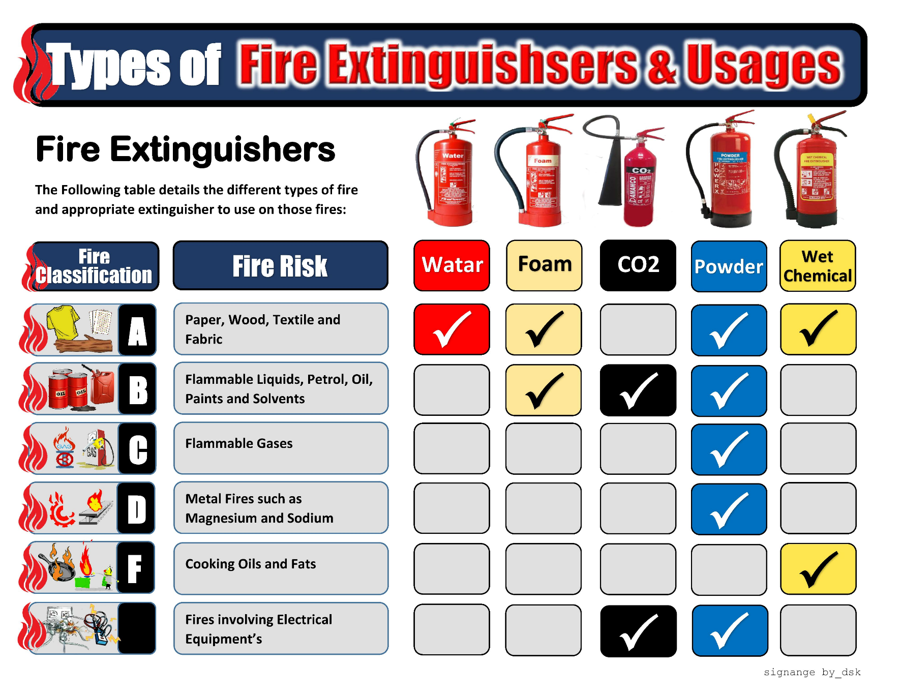
Please see nursery contingency plan for full evacuation process and safe locations.
Where to find our fire extinguishers:
Upminster 1:
- Kitchen – Water & CO2 extinguishers provided.
- Outside sand pit- foam & CO2 provided
- Behind front door- foam & CO2 provided

Upminster 2:
- Behind the front door Water & CO2 extinguishers provided.

How to use fire extinguishers:
How to use a water fire extinguisher (used for Class A fires)
- Make sure the fire does not involve electrics and is not near live electrical equipment unless using a water mist (deionised water) fire extinguisher and the voltage is less than 1,000 volts.
- If the fire is small and you are fully trained to extinguish a fire, stand at least 3 metres away with the appropriate extinguisher in hand.
- Break the tamperproof seal and pull the pin.
- Hold the operating lever in one hand and with the other, remove the discharge hose nozzle from its storage point. Hold the discharge hose 5cm from the nozzle.
- While holding the fire extinguisher, ensure it remains in the upright position.
- Face the fire extinguisher away from the fire, and gently squeeze the handle for a short sharp burst – this is to ensure it works.
- Aim the nozzle at the base of the fire (or back of the fire), gently squeeze the lever and then in a slow sweeping motion begin to sweep the nozzle from side to side across the fire.
- With the nozzle of the extinguisher aimed at the base of the fire, discharge the extinguisher fully to ensure the fire has been extinguished.

How to use a foam fire extinguisher (for Class A and B fires)
- When approaching the fire, try to contain any flowing liquids.
- Make sure the fire does not involve electrics and is not near live electrical equipment, unless using a deionised water-based foam fire extinguisher and the voltage is less than 1,000 volts.
- If the fire is small and you are fully trained to extinguish a fire, stand at least 3 metres away with the appropriate extinguisher in hand.
- Break the tamperproof seal and pull the pin.
- Hold the operating lever in one hand and with the other, remove the discharge hose nozzle from its storage point. Hold the discharge hose 5cm from the nozzle.
- While holding the fire extinguisher, ensure it remains in the upright position.
- Face the fire extinguisher away from the fire, and gently squeeze the handle for a short sharp burst – this is to ensure it works.
- (I) For contained liquid fires:
Aim the nozzle at the side of the fire, and gently squeeze the lever and release the extinguishing agent across the fire.
(II) For uncontained liquid fires:
Aim the discharge hose over the fire and gently squeeze the lever; allow the foam to drop onto the fire; and in a slow sweeping motion move the discharge nozzle along the fire, making sure the nozzle is not aimed at the fire as it will spread the flames. Consider using a dry powder extinguisher if available first to help slow the spread and then the foam to prevent the reignition.
(III) For non-liquid fires:
Aim the discharge hose at the base of the fire (or back of the fire), gently squeeze the lever and then in a slow sweeping motion begin to sweep the nozzle from the back to the front of the fire and slowly work across it.
- Discharge the extinguisher fully to ensure the fire has been extinguished.
- Look for signs of reignition – if there are signs, leave the area by your nearest exit (or suitable evacuation path) and advise the fire and rescue service on their arrival.

How to use a CO2 fire extinguisher (used for Class B and electrical fires)
- Make sure you do not place your hands on the fire extinguisher horn during or after use, as the hose will give you a freeze burn to your hands.
- If the fire is small and you are fully trained to extinguish a fire, stand at least 1-3 metres from the fire with the appropriate extinguisher in hand.
- Break the tamperproof seal and pull the pin.
- Raise the horn so it is at a 90 angle to the fire extinguisher cylinder.
- Hold the operating lever with both hands.
- While holding the fire extinguisher, ensure it remains in the upright position.
- Face the fire extinguisher away from the fire, and gently squeeze the handle for a short sharp burst – this is to ensure it works.
- (I) For Class B fires:
Aim the discharge horn to the side at the base of the fire, gently squeeze the lever and then in a slow, sweeping motion begin to sweep the nozzle from side to side across the fire, working your way to the back.
(II) For electrical fires:
Aim the discharge horn at the fire and – if possible – turn off the electrics; then aim the discharge hose into the equipment vents or continue to aim at the fire. If the electrics have been switched off before tackling the fire, then aim the discharge horn into the equipment vents or directly at the fire.
- Discharge the extinguisher fully to ensure the fire has been extinguished.
- Look for signs of reignition – if there are signs, leave the area by your nearest exit (or a suitable evacuation path) and advise the fire and rescue service on their arrival.
- Be mindful when placing the used fire extinguisher down, as on a wet surface it will freeze the water and prevent you from moving it.

When to use a fire extinguisher:
- Quick and proper use of a portable fire extinguisher can put out an incipient stage fire and prevent it from spreading. Once a fire has spread beyond its incipient stage, do not attempt to extinguish it with a portable extinguisher.

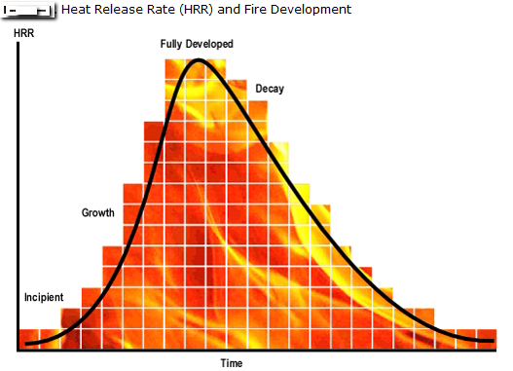

This policy was adopted: | Signed on behalf of the nursery: | Date for Review:
15/09/2025 | R Chudley | 15/09/2026

